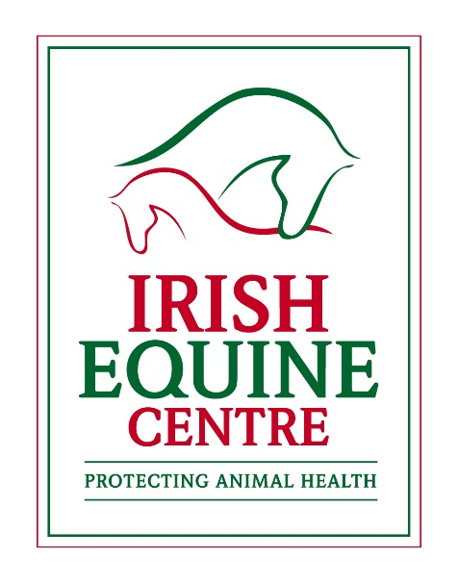

The Irish Equine Centre, in conjunction with Austin Davis Biologics Ltd., is delighted to provide horse owners and vets in Ireland with access to the EquiSal tapeworm test. This test uses saliva, which you collect yourself, to determine your horse’s tapeworm burden and if treatment is necessary.
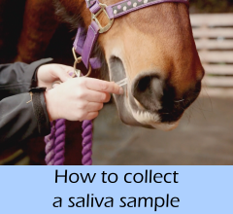
The control of worms in horses has received greater attention in recent years due to the emergence of resistance to the limited number of drugs available to treat such infections in horses. While much attention has focused rightly on control strategies for red worms and roundworms, as these are the major intestinal parasites in horses, far less attention has been given to the control of tapeworms in horses.
The equine tapeworm, Anoplocephala perfoliata, has long been associated with chronic conditions such as ill-thrift, weight loss, poor body condition and diarrhoea. Such conditions are quite nonspecific in nature and may be associated with other parasitic infections and with other diseases. More recently, tapeworms have been associated with spasmodic colic and ileocecal impactions, both of which can be fatal and it was shown that the risk of colic increased with the number of worms present. The tapeworm attaches to the gut lining in the region where the small intestine meets the large intestine (the ileocecal junction) via four suckers on the ‘head’ of the worm. This attachment leads to ulceration and inflammation of the local tissues and in extreme cases may lead to perforation of the gut wall.
Unlike the situation with other parasites, where young horses generally carry the greatest worm burden, horses of all ages can be infected with tapeworms and suffer from tapeworm-associated disease. In fact, the prevalence of infection is lower in foals and weanlings than adult horses as young foals do not graze sufficiently to acquire infection early in life and it then takes up to 16 weeks for the tapeworm to mature in the horse’s gut. Tapeworm infections in horses occur throughout the world and a study of 363 horses at slaughter in Ireland in the 1990s found evidence of tapeworm infection in fifty one percent of horses. The factors influencing the occurrence of tapeworms are not well understood but some farms seem to suffer repeated episodes of tapeworm-associated disease.
The regular use of anthelmintic drugs has been the mainstay of tapeworm control for many years, as it has been for the control of other equine parasites such as redworms and roundworms. Just as resistance has emerged in those parasites to the drugs used to treat them, resistance to the drugs used to treat tapeworms now appears to have emerged in the USA, according to a recent study. Most worryingly in that study, reduced efficacy of the 2 drugs licensed for tapeworm treatment was seen in the same group of horses on the same farm. The consequences of such resistance are likely to be increased tapeworm burdens and an increased risk of associated diseases in horses. As there are only 2 drugs licensed for tapeworm treatment in horses (praziquantel and pyrantel), there are potentially no other options available for the treatment of resistant tapeworm infections. While reports of diseases in the USA or elsewhere may seem far removed from one’s own farm or yard, the reality is that the horse industry is truly global and the movement of horses internationally, while vital for sport and trade, inevitably results in the movement of parasites and other infectious agents.
One reason why anthelmintic treatment has been the preferred method of tapeworm control was the lack of readily available and reliable diagnostic tests to detect the presence of tapeworms in the horse. Most horse owners are familiar with the faecal egg count test used to detect and count redworm (strongyle) eggs in faeces. Unlike redworm eggs, which are shed relatively consistently, tapeworm eggs are shed intermittently and so may not be detected using a single faecal egg count test. Furthermore, the faecal egg count method has not been standardised for the specific detection of tapeworm eggs. For these reasons, failure to detect tapeworm eggs on a faecal egg count test is not proof that the horse is not infected and, even where eggs are detected, the number of eggs is not an indicator of the degree of infection.
A blood test which detects antibodies to tapeworm proteins was developed by Austin Davis Biologics Ltd and has been available for some years; this test calculates a serum score and determines if the burden of infection is ‘low’, ‘borderline’, or ‘moderate/high’ based on this score. Those horses identified as having a low burden do not require treatment for tapeworms. This is a very useful test but the requirement for a blood sample necessitates a vet’s visit which may make it less attractive to some owners. It is recommended that testing is carried out every 6 months and testing should not be done for at least 4 months after worming for tapeworms.
As a follow on from the blood test, Austin Davis Biologics Ltd subsequently developed the EquiSal Tapeworm test, and kits for this test are now available to horse owners and vets from the Irish Equine Centre. The EquiSal test uses saliva rather than blood as the test matrix which means the sample can be collected directly by the horse owner, using the specially designed saliva collection swab. The swab is inserted through the space between the front and back teeth, onto the surface of the tongue and left there until the volume indicator on the swab turns pink. Horses must not eat, drink or be exercised for at least 30 minutes before collecting the sample for EquiSal testing. This part of the sample procedure is essential to obtain reliable results as increased saliva production interferes with the performance of the test and will result in a retest being required. Once the indicator has turned pink, the swab is placed in the tube provided which contains a preservative to keep the sample stable during transport. The barcode label provided must be placed on the tube along with the horse’s name and send the sample back to the Irish Equine Centre lab.
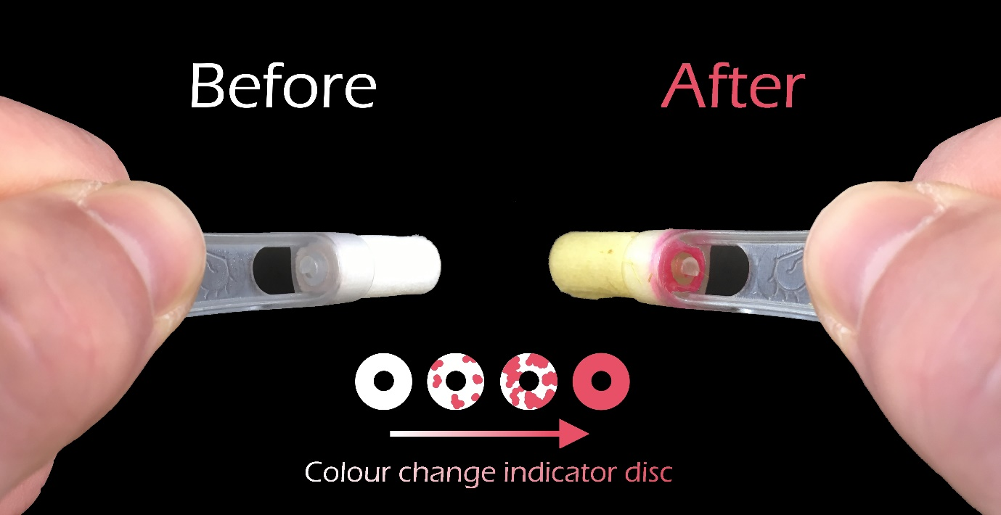
Similar to the blood test, the EquiSal test calculates a saliva score and determines if the burden of infection is ‘low’, ‘borderline’, or ‘moderate/high’ based on this score. As with the blood test, it is recommended that testing is carried out every 6 months and initial testing should not be done for at least 4 months after worming for tapeworms. However, as antibodies in saliva do not persist for as long as they do in blood, retesting using the EquiSal test can be carried out sooner, if needed, than with the blood test. In one study, the use of the EquiSal test led to an 86% reduction in tapeworm treatments which would also result in a significant cost saving.
While these tests are a great aid in determining the need for tapeworm treatment and in reducing the frequency of unnecessary treatments, effective control of tapeworms will only be achieved as part of an overall parasite control programme. Such control programmes should include a range of measures to reduce the risk of parasitic disease and the transmission of parasites at pasture which may be especially beneficial for tapeworm control.
For further information on the EquiSal test or to purchase a sampling kit please contact Mary Hennessey on 045866266 or email MHennessy@irishequinecentre.ie

